Learning Journey Assistant
  - Technical documentation and handover
Karthik Vijay
Student ID 21665347
CSE3CAP Capstone Project
Updated 8 October 2026

About this document
This document explains our Learning Journey Assistant code as it stood on 7 October 2026. It covers the system structure, database and APIs, AI workflow, and setup instructions. The dashboard currently uses local demo data. Some connections between Moodle, the AI engine and the dashboard still need to be completed. Hosting details and later code changes should be confirmed with the team before the final handover.
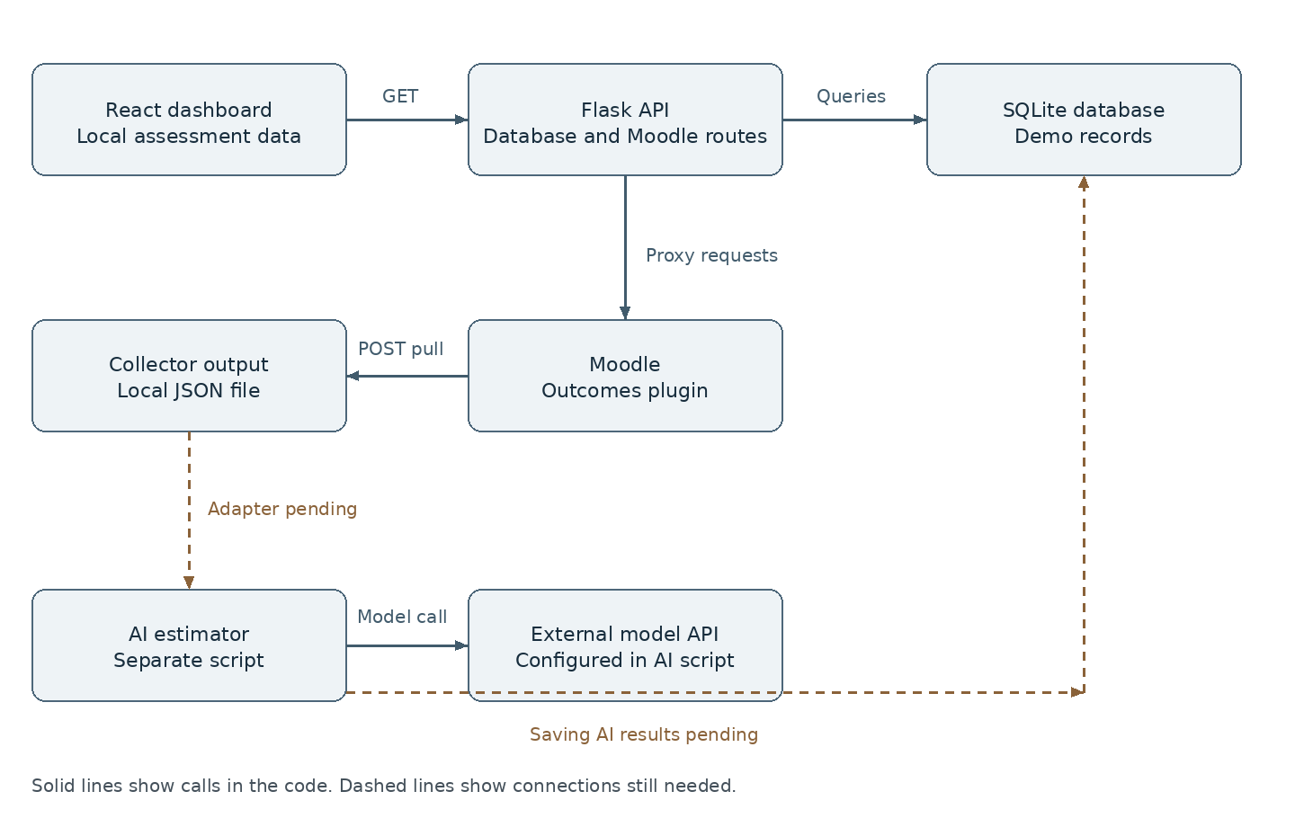
Figure 1 Current components and the connections still needed

Sections
CBLS 152 System architecture and components
CBLS 153 Database schema and API endpoints
CBLS 154 AI pipeline and data processing
CBLS 155 Setup deployment and handover

System architecture and components

System overview
Learning Journey Assistant is a student dashboard prototype intended to combine Moodle assessment information with AI estimates of learning-outcome mastery. The main version contains a React/Vite frontend, a Flask API, a SQLite database, a thin Moodle REST client, administrative Moodle data scripts and a custom read-only outcomes plugin. The AI estimator runs separately; Flask does not import or invoke it.
The dashboard currently reads assessments and subjects from our local database. The Moodle routes can request data separately, but there is no code that saves it into SQLite. We still need to connect the Moodle data, AI results and dashboard.

Component diagram
Solid connections below are present in source. Dotted connections are required integration work, not implemented calls.
System component diagram
The collector reads Moodle and writes a JSON file; the diagram's Moodle-to-JSON edge describes returned data, not a Moodle-initiated push. The AI file in main uses an older format than the file in the contract-update branch.

Components and responsibilities
Component | Source | Role and current boundary
Dashboard | frontend/src/App.jsx and components/ | Shows understanding, strengths, gaps and a trend summary; includes loading/error states
Data hook | frontend/src/hooks/useDashboardData.js | Fetches all assessments/subjects, joins by subject_id and computes display summaries
Frontend API | frontend/src/api.js | Uses fixed http://127.0.0.1:5000; no deployment environment setting
Flask | app.py | Exposes 14 GET routes, split between SQLite and upstream Moodle
Database | models.py and instance/learning_journey.db | Nine tables; bundled database has one demo student/subject/assignment and two assessments
Moodle proxy | moodle_client.py | Uses MOODLE_URL and MOODLE_TOKEN, makes GET requests to Moodle with a ten-second timeout
Live collector | scripts/pull_moodle_data.py | Uses standard-library POST calls; saves nested JSON; does not import it into SQLite
Outcomes plugin | moodle/local/ljaoutcomes/ | Reads course-linked definitions/scales with context and capability checks; no new tables
Administrative scripts | scripts/moodle/ | Seed synthetic data/rubrics/outcomes or export fixtures; not a general database migration tool
AI prototype | Prototype AI Gap Detection Engine/ | Calls an external model API; the updated input/output format is in the contract-update branch

Actual dashboard data flow
1. React mounts and calls getAssessments() and getSubjects() concurrently.
2. Flask reads the local SQLite tables. Each assessment derives subject_id through its assignment relationship.
3. The frontend matches subject_id to a subject name.
4. Category strings become display percentages: Achieved 95, Partially Achieved 60, Not Yet Achieved 25. Unknown/null values map to zero.
5. The hook averages these display percentages, counts assessment records above/below 50 and sorts records for the top/bottom three cards.
6. Components render the results. The hook fetches once on mount; it is not continuous polling.
These percentages are values chosen for the display. They are not calculated mastery scores from the AI. “Subjects on track” currently counts assessments, while its denominator counts subjects. Strengths/gaps show highest/lowest three records without category filtering, so they can overlap for small datasets. ProgressTrends shows an average, not a time series; its Improving tag is static. The header's two-gaps-this-week statement is static. Bottom-navigation changes active styling but does not select different content.
The frontend does not select/authenticate a student or filter results by student_id. It displays all assessments returned by the API. Student selection and access controls still need to be added.

Moodle hosting
Our Moodle setup used https://lja-moodle.australiaeast.cloudapp.azure.com on Azure, with Docker, MySQL 5.7, Moodle 3.6.2, PHP 7.3.1 and Caddy for HTTPS. The repository does not include the full hosting configuration, so the deployment owner needs to confirm the current settings.
The main version does not include a complete production deployment configuration. Flask starts with debug=True on port 5000. React's fixed loopback API URL would address each visitor's own machine in a hosted browser. Hosting Moodle therefore does not establish that the LJA application is deployed.

Branch comparison
The contract-update branch contains no app.py, models.py, moodle_client.py or scripts/moodle directory. It is not a drop-in replacement for the main ZIP. Its AI estimator follows the CBLS-40 categorical contract; its frontend differs and uses static demo values. Main has the dynamic data hook and the expanded backend/schema.
We should keep main as the base and review the updated AI file separately. Replacing the entire project with the contract-update branch would remove the newer backend and data scripts. The latest GitHub status needs to be checked before merging any changes.

Team confirmation
The diagram follows the calls and imports in the code. Dylan needs to confirm the final backend and deployment flow, Su Su the AI version and output format, and Lewis the final dashboard behavior. This section should be updated when those connections are finished.

Database schema and API endpoints

Database schema
The application uses SQLAlchemy with sqlite:///learning_journey.db. The application database is instance/learning_journey.db. Moodle's MySQL database is separate and is accessed through web services; it is not the Flask SQLite database.
Table | Columns and constraints
student | id INTEGER primary key; name VARCHAR(100) required
subject | id INTEGER primary key; code VARCHAR(20) required; name VARCHAR(100) required
competency | id INTEGER primary key; name VARCHAR(100) required
learning_outcome | id primary key; subject_id required FK to subject.id; competency_id required FK to competency.id; description VARCHAR(255) required
rubric_criterion | id primary key; outcome_id required FK to learning_outcome.id; description VARCHAR(255) required
enrolment | id primary key; student_id required FK to student.id; subject_id required FK to subject.id
assignment | id primary key; subject_id required FK to subject.id; name VARCHAR(150) required; SQLAlchemy subject relationship
assessment | id primary key; student_id required FK to student.id; assignment_id required FK to assignment.id; feedback_text TEXT, grade FLOAT, mastery_estimate VARCHAR(30), identified_gap TEXT nullable; assignment relationship
rubric_result | id primary key; assessment_id required FK to assessment.id; criterion_id required FK to rubric_criterion.id; level VARCHAR(20), points INTEGER nullable

All model IDs are integers. Relationships declare foreign keys, but SQLite foreign-key enforcement is not explicitly enabled in the application source. Mastery and rubric labels appear as comments, not enum/check constraints. Subject codes, enrolment pairs and assessment/criterion combinations have no unique constraints. There are no explicit Moodle IDs, due dates, grading timestamps, grade maximums, attempt numbers, rubric-level-definition tables, AI evidence fields or result-version/history fields.

Relationship diagram
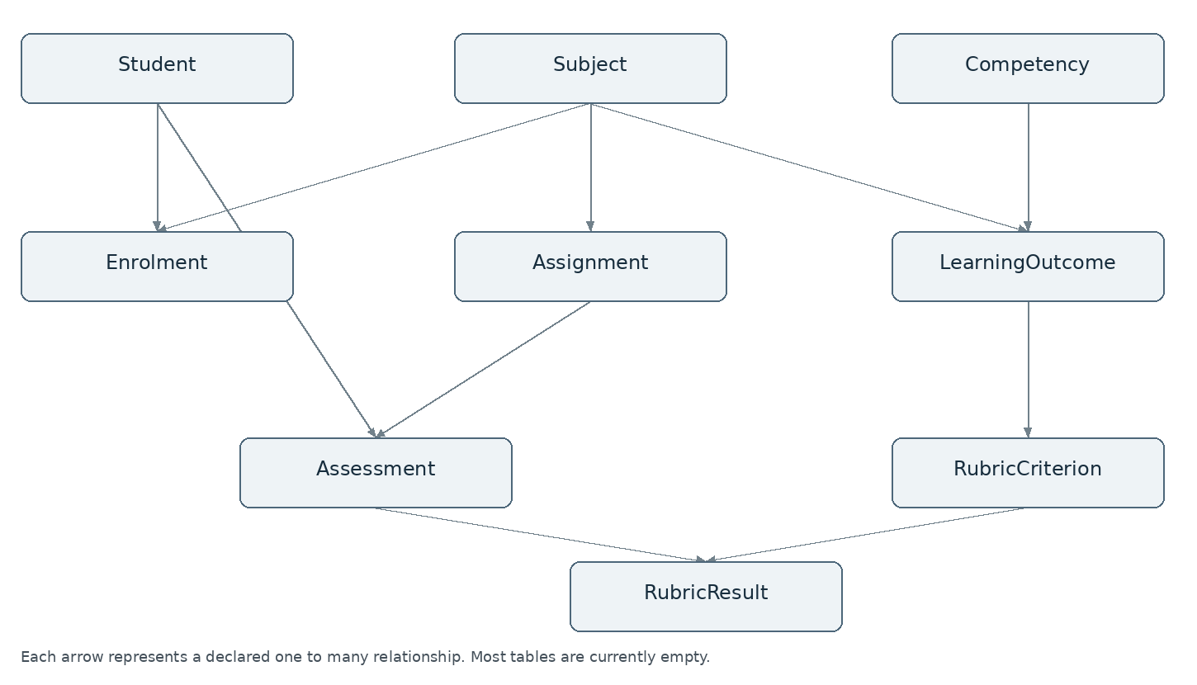
Figure 2 Database relationships
The database contains these tables, but most are still empty. The bundled database has: student 1; subject 1; assignment 1; assessment 2; competency, learning_outcome, rubric_criterion, enrolment and rubric_result each 0. Both assessments belong to the same demo student/assignment. They are demonstration rows, not evidence of live Moodle imports.

Local API contract
Development base: http://127.0.0.1:5000. All routes below use GET. No incoming authentication, per-student authorisation, pagination or filtering is implemented. CORS(app) uses its broad default. There are no write/import/AI-inference endpoints in app.py.
Route | Success response
/ | message: API-running text
/students | students array of id/name
/subjects | subjects array of id/code/name
/assessments | assessments array of id, student_id, subject_id, feedback_text, grade, mastery_estimate, identified_gap
/subject/<subject_id> | One id/code/name object
/assessment/<assessment_id> | One assessment object with the same fields as the list
/rubric/<criterion_id> | One id/outcome_id/description object; not a whole rubric
/student/<student_id>/summary | student_id, student_name, strengths, gaps, assessment_count

Missing subjects, assessments, criteria or students return HTTP 404 with an error string. A known student with no assessments returns empty strengths/gaps and count zero. /student/.../summary puts identified_gap into strengths for Achieved assessments, and into gaps for the other two category strings. An achieved result with an empty gap can therefore produce an empty string in strengths. Unexpected labels are ignored by both category lists.
Example assessment from the bundled demo database:
{
"id": 1,
"student_id": 1,
"subject_id": 1,
"feedback_text": "Strong normalization skills.",
"grade": 85.0,
"mastery_estimate": "Achieved",
"identified_gap": ""
}
For these demo rows, the summary is student_id 1, student_name Test Student, strengths containing an empty string, gaps containing Query optimization and assessment_count 2. The list routes read all records; getStudents/getAssessment exist in frontend/api.js but the dashboard hook currently uses only getSubjects/getAssessments.

Moodle proxy routes
The Flask client reads MOODLE_URL and MOODLE_TOKEN at import time. Missing either variable prevents startup even when only local routes are needed. MOODLE_URL is the site root, not the complete REST server URL. The wrapper appends /webservice/rest/server.php and sends the token in a GET query string.
Flask route | Upstream function | Implemented parameters and outer response key
/moodle/courses | core_course_get_courses | No function-specific parameters; courses
/moodle/course/<course_id>/outcomes | local_ljaoutcomes_get_course_outcomes | courseid; outcomes
/moodle/course/<course_id>/grades | gradereport_user_get_grade_items | courseid only; grades
/moodle/course/<course_id>/assignments | mod_assign_get_assignments | courseids[0]; assignments
/moodle/rubric/<area_id> | core_grading_get_definitions | areaids[0] only; rubric_definitions
/moodle/assignment/<assignment_id>/grades | mod_assign_get_grades | assignmentids[0]; grades

These routes keep the original Moodle response inside an outer key. For example, the outcomes route returns an outer outcomes object containing courseid and an outcomes list.
Each outcome includes id, shortname, fullname, description, scaleid, scale and scale_levels. The scale field contains comma-separated labels. scale_levels contains value/label pairs, such as value 1 for Not Yet Achieved. The older API_CONTRACT.md example shows scale as an array, so it needs to be updated to match the plugin code.
Moodle JSON containing exception is converted to MoodleAPIError and then HTTP 502 with {"error": "..."}. requests HTTP/timeout/connection errors and JSON decoding errors are not wrapped, so they escape that handler and may become HTTP 500. Warnings are passed through but not interpreted. Do not promise 502 for every upstream failure.

Rubric and grade IDs
The historically tested collector/handoff uses core_grading_get_definitions with cmids[0], areaname=submissions and activeonly=1. The Flask wrapper instead sends areaids[0]. A local check confirmed that the two files send different parameters. The proxy needs to be checked against our installed Moodle function. The /moodle/rubric route currently expects area_id. It should not be described as accepting a rubric definition ID.
The retrieval sequence used in our earlier Moodle checks is: discover assignment ID/cmid; fetch definition via cmid; fetch instances via definitionid; fetch assignment grades via assignment ID; join instance.itemid to grade-record.id, then read userid; join selected levelid to the level within the matching criterion/definition. Rater ID is the marker, not the student. Keep attempt number and separate assignment grade.
Our earlier CSE3CYB test used: course 9, cmid 26, assignment 10, definition 99, instances 157/158, grade records 40/41, students 6/7. These values must be discovered again for another database. No proxy route exposes core_grading_get_gradingform_instances even though the collector supports it. The gradebook proxy supplies no userid; verify the resulting account/default scope instead of assuming a selected student's grades.

Remaining backend work
Define explicit Moodle/backend mappings and an import/upsert workflow; resolve rubric request parameters and student grade scope; add authentication and student access controls before private use; migrate existing databases rather than relying on create_all(); agree evidence/history storage and response contracts. The expanded schema addresses several earlier gaps. The importer and full integration still need to be completed.

AI pipeline and data processing

Pipeline status
The two branches contain different AI files. Neither version is called by app.py yet. The backend still needs a way to prepare Moodle data, run the AI and save its output.
Version | Input | Output | Compatibility
main/mastery_estimator.py | Two strings: rubric and feedback | Array of learning_outcome/mastery_score/evidence records | Older temporary numeric contract
feature-CBLS-38-contract-update estimator | One structured record | One categorical result with IDs, competency, evidence and identified_gap | Matches the current sample runner's call shape and CBLS40.md

In main, test_samples.py passes one record to a function that expects two arguments. This causes a TypeError before a model request can run. The contract-update branch uses the correct one-record format, but it does not contain the newer main backend or dynamic dashboard. The team needs to review the updated AI file before merging it.

Moodle extraction before AI
scripts/pull_moodle_data.py uses LJA_TOKEN and an optional LJA_MOODLE_URL full endpoint override. Its default endpoint is the historical hosted Moodle REST server. It discovers assignments, reads course outcomes, assignment grades/submissions, definitions and rubric instances, then retrieves grade reports for users found in the grade responses.
The nested output contains the discovery response and courses. Each course holds courseid, outcomes, assignments and grade_reports. Each assignment entry holds assignmentid, cmid, grades, submissions, definitions and instances_by_definition. Warnings remain in the raw JSON. Exceptions stop collection before writing a new output; a prior output file may still exist and should not be mistaken for a fresh successful pull.
This collector uses POST, unlike the thin Flask Moodle wrapper's GET. It does not create a complete enrolment list: students without grade records can be missed. It writes a version file, not SQLAlchemy rows or ready-made AI input records.
An adapter still needs to join instance.itemid to assignment-grade record id and userid, map each levelid within the correct criterion, extract the corresponding feedback and resolve the agreed learning-outcome/competency mapping. Do not infer mappings solely from criterion position. The fixture scripts' ordering is a dataset convention, not a universal Moodle relation.

Updated AI workflow
1. Validate required input fields/types and the Weak/Adequate/Strong rubric enum.
2. Build a prompt from competency, learning_outcome, rubric_criterion, rubric_level and feedback.
3. Create the model API client using the provider key stored in ANTHROPIC_API_KEY.
4. Send the prompt to the model configured in mastery_estimator.py, with a maximum response length of 512 tokens. The provider account and model access must be checked before running a paid request.
5. Join returned text blocks, strip optional Markdown fences and parse JSON.
6. Check mastery_estimate and identified_gap types and validate the three mastery categories.
7. Return original student/subject/outcome/competency fields and evidence copied from input, combined with the model's judgment.
Input example:
{
"student_id": 3,
"subject_code": "CSE1DBS",
"assignment": "CSE1DBS Assignment 1",
"competency": "Technical Implementation",
"learning_outcome": "CSE1DBS-LO1",
"rubric_criterion": "Query Design & Normalization",
"rubric_level": "Adequate",
"feedback": "The solution is mostly correct but needs stronger technical detail."
}
Example output format:
{
"student_id": 3,
"subject_code": "CSE1DBS",
"learning_outcome": "CSE1DBS-LO1",
"competency": "Technical Implementation",
"mastery_estimate": "Partially Achieved",
"identified_gap": "Technical detail needs improvement",
"evidence": {
"rubric_level": "Adequate",
"feedback": "The solution is mostly correct but needs stronger technical detail."
}
}
assignment and rubric_criterion are accepted in the input but absent from the final output. The adapter must preserve identifiers needed to attach a result to an assessment and avoid collisions across assignments/outcomes. Student ID and assignment are not sent in the prompt; outcome/competency and feedback are sent. Synthetic data is the recorded prototype scope.

Output format and validation
CBLS40.md uses an evidence object; CBLS71.md illustrates evidence as a string. The newer estimator returns an object. Resolve this explicitly with the AI/frontend owners rather than saying both contracts are the same. CBLS40.md also says the data script does not pull rubrics/outcomes, which is stale relative to the supplied expanded collector.
The newer parser checks required fields and enum values but does not reject extra keys or explicitly ensure the parsed top-level value is an object before field checks. Input validation permits empty text and extra fields; isinstance(student_id, int) also accepts Python booleans. The script does not yet include retries, a configured request timeout, confidence estimates, saved inference records or an accuracy evaluation.
The old main parser checks an array and required field types but does not enforce score 0–100, reject extra fields or robustly validate each item shape. A mocked parse accepted score 150. Its prompt asks for exact fields/ranges, which does not substitute for code validation.

Connecting results to storage and dashboard
The expanded assessment table can store categorical mastery_estimate and identified_gap. It does not store evidence, outcome-specific AI result IDs or history. Rubric_result stores a criterion/level/points link, but its archived table is empty. No estimator code commits to these tables.
The frontend maps categorical labels to display percentages 95/60/25. Those are display values, not model scores or Moodle grades. The current dashboard shows all assessments and no student filter; its trend label is not supported by timestamps or a longitudinal series.
A complete implementation needs agreed evidence format, criterion-to-outcome mapping, student/assignment/attempt identity, adapter, inference invocation and persistence, then a student-scoped dashboard contract. Personalised learning-plan and quiz generation were proposed goals but no corresponding implementation was found in these versions.

Verification and remaining tests
Local checks confirmed the main function mismatch and tested the newer parser with sample responses. The parser kept the original IDs and feedback, and rejected invalid mastery and rubric labels. These checks did not contact the model API, measure AI accuracy or test the full app.
Required next checks: review/merge the intended estimator; test representative synthetic cases against an agreed expected outcome; verify invalid JSON/top-level shapes and provider errors; measure whether rubric and feedback support the estimate; run one complete authorised Moodle-to-result-to-dashboard case. The sample runner triggers real model calls once compatible and configured, so it should only run with authorised credentials/budget.

Setup deployment and handover

Scope and prerequisites
These instructions cover our current development setup. The full application deployment is still pending. The team should check the guide against the complete CBLS-155 requirements before closing the handover.
Required locally: Python with venv/pip, Node/npm compatible with the frontend lockfile, the main source version and authorised Moodle service credentials for live calls. The lockfile lists Vite 8.2.1 and plugin-react 6.0.5 with Node ^20.19.0 or >=22.12.0. React is locked at 19.2.8. These are the versions listed in the project files. The repository does not include a backend requirements file or a fixed Python version. Historical development used Python 3.14.4; dependency compatibility must be verified on the selected environment.
The AI folder's requirements.txt contains anthropic without a pin. Docker/PHP/MySQL are only needed for a separate Moodle installation or seed-script testing; consuming an existing Moodle API does not require local Moodle.

Backend setup on Windows PowerShell
Open a terminal at the extracted main repository root. Run separately:
py -m venv .venv
.\.venv\Scripts\python.exe -m pip install Flask Flask-Cors Flask-SQLAlchemy requests
These packages are required by the Python imports. After testing the setup, the team should record their working versions in a requirements file. There is no .env loader in app.py or moodle_client.py, so merely writing a .env file will not set the variables.
Set the site root and enter the service token privately:
$env:MOODLE_URL = 'https://lja-moodle.australiaeast.cloudapp.azure.com'
$secret = Read-Host 'Moodle service token' -AsSecureString
$env:MOODLE_TOKEN = [System.Net.NetworkCredential]::new('', $secret).Password
.\.venv\Scripts\python.exe app.py
The client reads both environment variables at import time. They are required to start the current app even when only SQLite routes are used. Leave the terminal running. The Moodle address above is the one used in our project handoff. Check that the site is available before making live requests.
Use http://127.0.0.1:5000/ and /students, /subjects, /assessments to check local responses. Expect the bundled demo database to contain one Test Student, one CSE1DBS subject, one assignment and two assessments. Do not assume its IDs correspond to the hosted Moodle users.
Do not run seed_test_data.py routinely: it blindly appends demo rows and commits multiple times, is not idempotent and can duplicate them. Its “do not commit” comment does not change the fact that it is already included in the uploaded version. Back up an existing instance/learning_journey.db before deliberate seeding or schema work. create_all() does not update existing table definitions to a changed model schema.

Frontend setup
In a second terminal at the same repository root:
Set-Location frontend
npm ci
npm run dev
Open the URL Vite prints. The frontend uses http://127.0.0.1:5000 directly; Flask must be running on the same machine. No Vite proxy or configurable API base was found. Check its loading/error state and compare displayed assessments with the JSON responses. For two seeded categories Achieved and Not Yet Achieved the display average is 60%, derived from 95 and 25, not from grades 85 and 35.
Available checks:
npm run build
npm run lint
A successful build checks bundling, not live data integration. The frontend build and lint checks still need to be run in the final test environment.

Read live Moodle into a local version
From the repository root, using the same authorised service token:
$env:LJA_TOKEN = $env:MOODLE_TOKEN
.\.venv\Scripts\python.exe .\scripts\pull_moodle_data.py --output moodle_data.json
Remove-Item Env:LJA_TOKEN
LJA_MOODLE_URL, if supplied, must be the FULL /webservice/rest/server.php URL. It differs from MOODLE_URL, which is the site root. Review JSON exception/warning information and extraction counts. The script stops before writing a new file if collection fails. This command does not import anything into SQLite or run AI. Keep output local and outside shared commits.
Variable | Consumer | Meaning
MOODLE_URL | moodle_client.py | Moodle site root, required at import
MOODLE_TOKEN | moodle_client.py | Service token, required at import
LJA_TOKEN | scripts/pull_moodle_data.py | Service token for POST collector
LJA_MOODLE_URL | Collector | Optional full REST endpoint override
ANTHROPIC_API_KEY | AI SDK | Provider key for standalone inference

The backend client currently sends tokens in a GET query string; the collector sends them in POST data. Before production, align the client with the safer body-based pattern and avoid logging credential-bearing URLs. Do not include any real credential in these documentation files.

AI prototype setup
First reconcile the contract-branch estimator with main. Main's sample runner fails on its argument mismatch. Do not overwrite the entire main checkout with the older feature ZIP: it lacks the current backend/data scripts and has a different frontend.
Install the estimator dependency into the same venv if the team authorises a prototype run:
.\.venv\Scripts\python.exe -m pip install -r '.\Prototype AI Gap Detection Engine\requirements.txt'
Set ANTHROPIC_API_KEY privately in the terminal/environment using the provider key-management process. No key value is supplied here. Use the model configured in mastery_estimator.py and check the provider account quota first. test_samples.py contains three synthetic Strong/Weak/Adequate cases; with the newer estimator it will call the provider for each case. The local documentation checks did not make live model requests.

Existing Moodle setup and recovery
Our earlier Moodle environment used: Azure VM lja-moodle in Australia East; Ubuntu; Docker Compose; Moodle 3.6.2/PHP 7.3.1; MySQL 5.7; Caddy HTTPS. These are the versions used during the migration. Confirm the current server configuration before making changes. Export/restore the exact compatible image/configuration before any runtime change. The original migration failed when a newer aesr/moodle image used PHP 8.4 with the old code.
For another authorised Moodle test instance, install local/ljaoutcomes from the repository plugin source, complete Moodle's admin upgrade and add local_ljaoutcomes_get_course_outcomes to the restricted LJA Service. The plugin validates course context and requires moodle/course:view and gradereport/user:view. It creates no tables and returns existing course-linked definitions/scales, not student achievements.
Moodle administrative scripts must run only on a separate backed-up test copy. Copy them into /var/www/html/admin/cli/ so the relative configuration path resolves. Run generate_lja_data.php, setup_rubrics.php, then setup_learning_outcomes.php. export_rubrics.php is an optional read-only fixture export. Use the real test container name from Docker, not the historical live name blindly.
The generator uses split subject enrolments and random data/passwords. Revised reruns preserve saved grades/feedback; existing rubrics are skipped. It is not a migration/repair tool for incomplete old instances. Fresh seed results will not exactly reproduce the hosted dataset.
Recovery requires backups of Moodle SQL, Moodle code/plugins/configuration and moodledata, plus Compose/Caddy settings and the compatible Docker image. Keep secrets out of GitHub. Back up the application SQLite instance separately while writes are stopped or with a database-safe backup. Keep dated checksums and test restoration on a separate environment before replacing a live installation. The repository does not include the full cloud backup and recovery configuration.

Preparing for deployment
Before deploying the complete app:
- Confirm application hosting and a shared HTTPS backend URL; replace the fixed browser loopback base with a deployment setting.
- Use a production WSGI service and disable Flask debug mode; the supplied app.py development entry point is not the deployment setup.
- Implement login/student authorisation, restrict CORS and protect Moodle-proxy access.
- Store secrets privately; persist/back up SQLite or choose the team's database strategy; provide migration/versioned configuration.
- Integrate the chosen AI version, Moodle mappings/importer and result persistence.
- Verify upstream failures, timeouts, rate limits, warning handling and operational logging without tokens.
- Run system and user acceptance tests before treating CBLS-108 deployment as done.
These items still need implementation and testing.

Known limitations and responsible owners
Finding | Evidence / next owner
Live Moodle data not imported into dashboard DB | No importer/AI persistence path found; Backend/Data/AI owners
Main AI sample call incompatible | Reproduced TypeError; AI/Backend owners review contract branch
Rubric proxy sends different parameters from tested collector | areaids versus cmids/areaname/activeonly; Dylan
Unhandled upstream network/JSON errors | Only MoodleAPIError caught; Dylan
Evidence contract differs | CBLS40 object versus CBLS71 string; Su Su and Backend
Dashboard unscoped and misleading labels | All assessments, assessment-count numerator, static alert/trend tags; Lewis
Schema has no external ID/history/grade max/attempt storage | models.py inspection; Backend/Data owners
No app authentication/production config | app.py and frontend inspection; Backend/Frontend owners
Complete cloud configuration absent | ZIP inventory; deployment owner
Moodle enrolment/test-account cleanup and cron/error-display notices | Historical handoff listed pending; Karthik verify current state

Handover and acceptance checks
Karthik maintains documentation/data-source notes; Dylan confirms schema/API/importer/deployment; Su Su confirms AI contract and outputs; Lewis confirms frontend/student metrics; the testing owner supplies end-to-end evidence. Confirm the current responsibilities with the team before the final handover.
Before closing subtasks, compare the four documents with the full Jira descriptions, review them against the latest branch, add the documents to the team repository and request review. For final architecture/setup, obtain the actual deployed URLs/configuration and a reproducible end-to-end test. The documents should be updated when the remaining integration work is finished.

Checks and remaining tests
The local checks covered Python syntax, database tables and counts, the differences between branches, AI response parsing, Moodle request parameters and frontend display values. The checks used sample responses and did not make live Moodle or model requests, change database records or run deployment tests. Flask routes, the frontend build and PHP scripts still need to be tested in the final environment.
Our earlier Moodle checks returned 8 subjects, 32 project assignments, 80 accessible rubric results and 32 outcomes. PHP syntax checks and a temporary rubric activation test also passed earlier. These results do not prove the newer Flask proxy or complete application works. Some older README notes predate those checks and should be updated.

